**Priority Queue Implementation Using Array**

**Done By:** Rohit Karunakaran **Roll no:** 58

**Date :** 05-10-2020

**Aim:** To implement a priority queue using array

**Data Structure used :** Priority Queue, Array

**Algorithms**

**1. Algorithm for enqueue**

Input: An Array implementation of Priority Queue (P_Q[SIZE]), with front pointing to the first element and rear pointing to the last element in and an element E to be inserted into the queue, with a priority P

Output: The Priority Queue with the element E inserted at the end

Data Structure: Priority Queue

Steps:

Step 1: if(rear == SIZE) then

Step 1: print(“The queue is full insertion not possible”)

Step 2: exit(1)

Step 2: else

Step 1: if(rear == -1) then

Step 1: front ++

Step 2: EndIf

Step 3: ++rear

Step 4: Q[rear].elem = E

Step 5: Q[rear].priority = P

Step 3: EndIf

**2. Algorithm for dequeue**

Input: An Array implementation of Queue (Q[SIZE]), with front pointing to the first element and rear pointing to the last element in the queue.

Output: The element E which has the lowest priority is removed form the priority queue

Steps

Step 1: if(front == -1) then

Step 1: print(“The Queue is empty”)

Step 2: exit(1)

Step 2: else

Step 1: ptr = front

Step 2: lowestPriority = Q[front].priority

Step 2: while(ptr<=rear)

Step 1: if(Q[ptr].priority<lowestPriority) then

Step 1: lowestPriority = Q[ptr].priority

Step 2: pos = ptr

Step 2: endif

Step 3: ptr++

Step 3: endWhile

Step 4: E = Q[pos].elem

Step 5: While(pos>front) do

Step 1: pos--

Step 2: Q[pos+1] = Q[pos]

Step 6: EndWhile

Step 7:if(front==rear) then

Step 1: front=-1

Step 2: rear = -1

Step 8:else

fornt = front +1

Step 9: endif

Step 3: endif

**Description of the Algorithm:**

In this algorithm the time complexity of insertion is O(1) while deletion is O(n).

**Program code:**

/* Priority Queue implemetation using dynamic array

* Done By : Rohit Karuankaran

* */

#include <stdlib.h>

#include <stdio.h>

#define SIZE 32

typedef struct priority_queue

{

int **Q;

int size;

int front;

int rear;

}pqueue;

void initQueue(pqueue *q)

{

q->size = SIZE;

q->Q = (int**) malloc(q->size*sizeof(int*));

for (int i = 0;i<q->size;i++)

q->Q[i] = (int*)malloc(2*sizeof(int));

q->front = -1;

q->rear = -1;

}

void delQueue(pqueue *q)

{

for(int i =0;i<q->size;i++)

free(q->Q[i]);

free(q->Q);

}

void enQueue(pqueue *q,int elem,int p)

{

if(q->rear>=q->size)

{

printf("The Queue is full Inseriton not possible\n");

delQueue(q);

exit(1);

}

else

{

if(q->front==-1)

{

q->front=q->front+1;

}

q->rear = q->rear+1;

q->Q[q->rear][0] = elem;

q->Q[q->rear][1] = p;

return;

}

}

int deQueue(pqueue *q)

{

if(q->front == -1)

{

printf("QUEUE IS EMPTY THERE IS NO ELEMENT TO DELETE\n");

return -1;

}

else

{

int ptr = q->front;

int pos =ptr;

int priority = q->Q[q->front][1];

while(ptr<=q->rear)

{

if(q->Q[ptr][1]<priority)

{

priority = q->Q[ptr][1];

pos = ptr;

}

ptr++;

}

int elem = q->Q[pos][0];

if(pos !=q->front)

{

while(pos>q->front)

{

pos--;

q->Q[pos+1][0] =q->Q[pos][0];

q->Q[pos+1][1] =q->Q[pos][1];

}

}

if(q->front==q->rear)

{

q->rear =-1;

q->front =-1;

}

else{

q->front +=1;

}

return elem;

}

}

void displayQueue(pqueue *q)

{

int i = q->front;

if(q->front==-1)

{

printf("EMPTY");

return;

}

while(i>=0&&i<=q->rear)

{

printf("%d ",q->Q[i][0]);

i++;

}

}

int main()

{

pqueue *myQueue = (pqueue*) malloc(sizeof(pqueue));

int RUN = 1;

int elem;

int priority;

int choice;

initQueue(myQueue);

while(RUN)

{

printf("=======================\n");

printf(" Menu\n");

printf("=======================\n\n");

printf("1.Enter into the queue\n");

printf("2.Remove from the queue\n");

printf("3.Display the queue\n");

printf("4.Exit\n");

printf("Enter your choice : ");

scanf("%d%*c",&choice);

switch(choice)

{

case 1: printf("Enter the element you want to enter into the Queue : ");

scanf("%d%*c",&elem);

printf("Enter the priority of the element : ");

scanf("%d%*c",&priority);

enQueue(myQueue,elem,priority);

break;

case 2: elem = deQueue(myQueue);

printf("The element remove is :%d\n",elem);

break;

case 3: printf("The Queue is: ");

displayQueue(myQueue);

printf("\n");

break;

case 4: RUN = 0;

break;

default: printf("Enter a valid input\n\n");

}

}

/*

insert(myQueue,32);

insert(myQueue,21);

displayQueue(myQueue);

*/

delQueue(myQueue);

printf("\nExiting.....\n");

}

**Sample input/Output:**

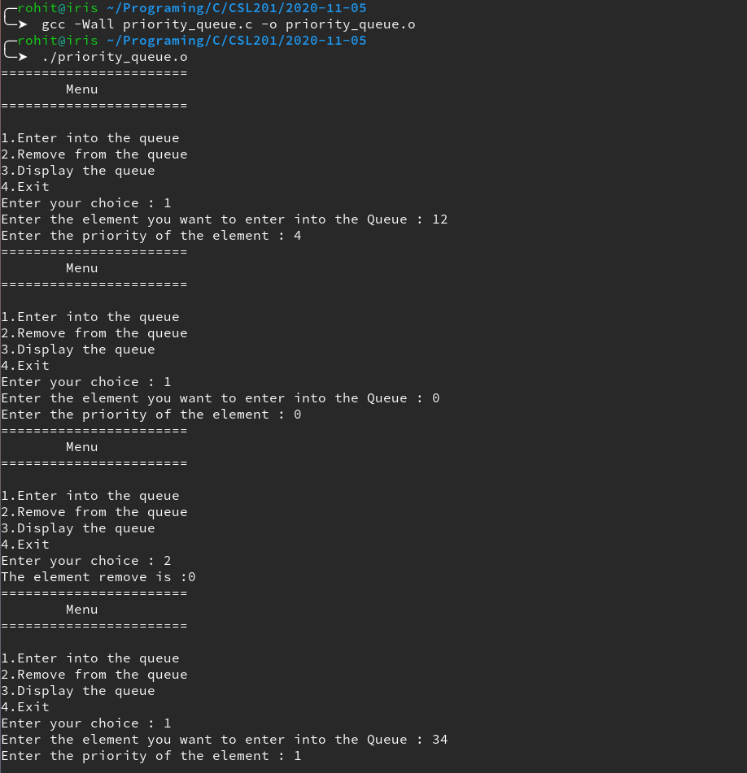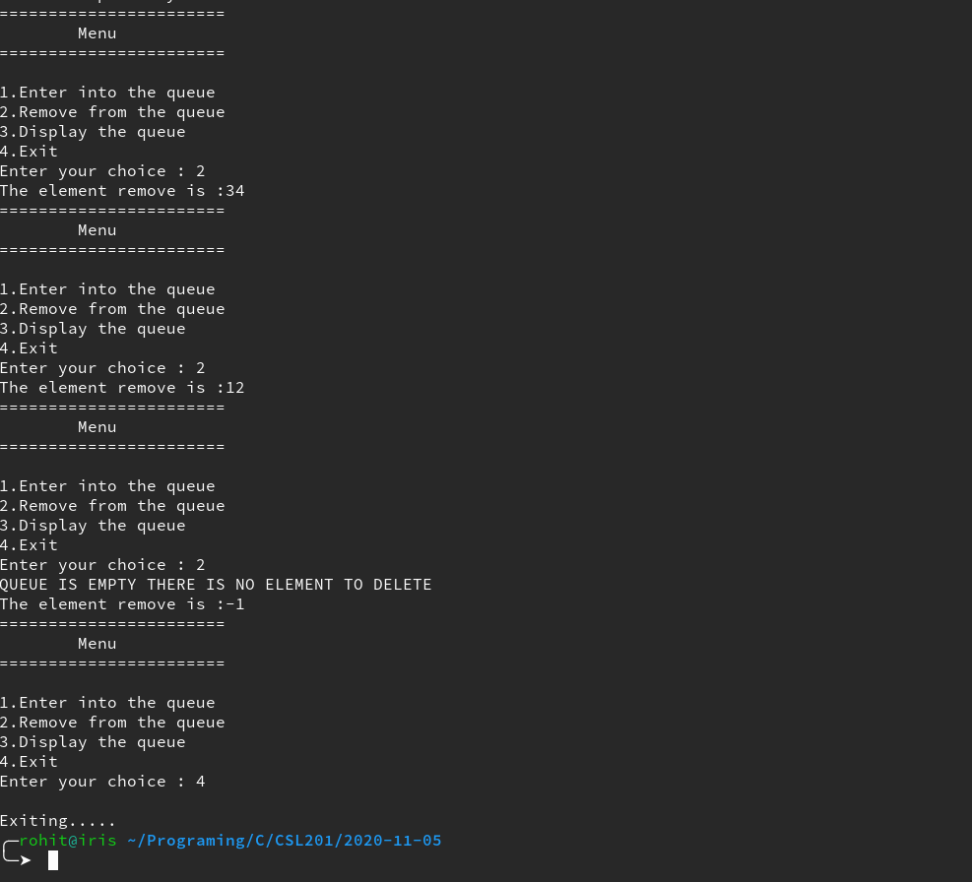

**Result:** The Program compiled successfully and the desired output was obtained.